User Manual of the DSSAT-PEST Package

1. Software installation

1.1. Installation of DSSAT
Users first need to download the DSSAT software installation package (http://dssat.net/downloads/dssat-v46). Click "Install DSSAT v4.6" to install DSSAT v4.6. It is recommended to install DSSAT in the default path, or the root directory on the C disk (Fig.1). The current version of DSSAT-PEST is applicable to DSSAT v4.6.
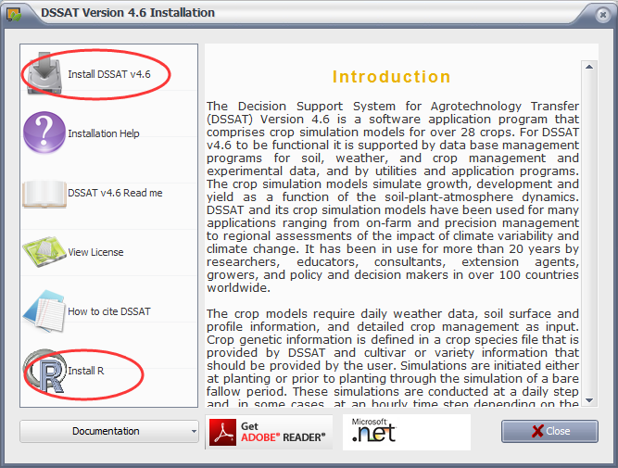
Figure 1. Screenshot for the installation of DSSAT software.

1.2. Installation of R language programs
The authentic R language program is available on the following home page (https://www.r-project.org/). Users can download an additional program (Rstudio) to make R easy to edit. R language and RStudio are recommended to be installed in their default directories as well. When users run the DSSAT-PEST program in R, the working path should be set as the same path of the DSSAT-PEST package.

1.3 Installation of DSSAT-PEST package
After decompressing the DSSAT-PEST package, save it to a path that is not too complicated and the folder name should not exceed 20 characters. Pay particular attention to pathnames. They should not contain spaces or non-English characters.

2. DSSAT-PEST documentation

2.1. Basic principles of DSSAT-PEST
The PEST (Parameter ESTimation) software (Malone et al., 2010; Nolan et al., 2010) was developed by Dr. John Doherty of Watermark Digital Computing Consulting in Brisbane, Australia. It is a model-independent software to estimate parameters and analyze uncertainty. It can be called in any programming language. Users do not need the source code, nor do they need to know about the internal principles. PEST makes no changes to the model but runs the model by the input and output files.
The basic principle of PEST is to use the Gauss-Marquardt-Levenberg method, a nonlinear evaluation method. This method combines the advantages of the inverse Heisen and the steepest descent method, which can converge faster and more effectively. It is a fast optimization method. As long as the initial parameters are set reasonably and the insensitive parameters can be eliminated, the optimization process can provide good results very fast.
The disadvantage of PEST is that it is often difficult to accurately select the appropriate initial parameters, which can lead to the final optimization result falling into a local optimal solution rather than a global optimal solution. In order to overcome this problem, reasonable ranges of initial values should be determined initially according to user experience. Next, a Monte Carlo method is used to randomly generate several vectors of initial parameters. Third, these parameters are then run in turn and calculated for their individual fitness values (Eq. 1). Fourth, these parameters are sorted according to their fitness values (He et al., 2012) and then selected according to a certain filter ratio. Finally, the selected initial parameters are optimized by PEST. Fitness value ranges between 0.0 and 1.0, and reflects the goodness of fit between the predictions and the observations. The closer the fitness value is to 1.0, the higher the fitting degree will be.
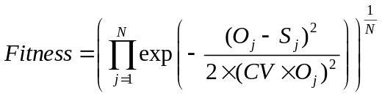 （1）
where 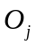 is the th observation; 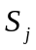 is the th prediction; 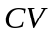 is the average coefficient of variation of the th variable; and 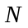 is the total number of observations. At present, DSSAT-PEST is suitable for most crops in DSSATV 4.6, except for pineapple, sunflower, and sugarcane because of the different formats of output variables. In addition, observations are not available for some crops in the example experiments included in the DSSATV 4.6 database, including pepper, cabbage, bahia grass, and brachiaria, so these crops were not tested.

2.2. DSSAT-PEST file structure
The DSSAT-PEST package contains four types of files: input files, output files, main program file, and running file. The running file is the file required to run the program, and it does not need users to modify or view it.
2.2.1, Input file of "CropCultivar.csv"
This input file contains information such as serial number (No.), crop types, genotype file name, flag, cultivar names, etc. (Fig. 2). This file is used to select the crops and varieties that need to be optimized. The flag value needs to be set as 1 if a specific crop and its variety are determined, while the other flags should be set as 0 (Fig. 2). The cultivar name includes the code and the name of a given crop variety in the DSSAT database.
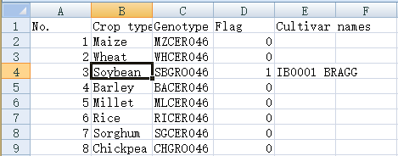
Figure 2. Components of the CropCultivar.csv file.
2.2.2. Input file of "ParameterOutput.csv"
This file contains information about crops (Crop), genetic parameters and output variables (Output), selection status, range of genetic parameters (Min value and Max value), markers of genetic parameters, group markers of output variables, weights of output variables, definition of genetic parameters, and observation values (Fig. 3). In this file, there are three kinds of content that can be modified by users: the selection of genetic parameter condition, parameter range (Min value and Max value), and weight (Weight) of the output variables that need to be optimized. Users can choose the parameters of a given cultivar for optimization. A parameter value of "1" indicates that the parameter will be estimated and a value of "0" indicates that the parameter will be left intact and not estimated. An observation of "1" (default value) indicates that the output variable is the optimization objective, while a value of "0" indicates that the output variable is not involved. The program automatically rejects the output variables without relevant observed data so that they will not be considered as the optimization objective. The user can adjust the parameter range (Min value and Max value), however the initial values must be within the ranges and not equal to the maximum or minimum value. The group markers of output variables are used to classify different output variables according to their units for the purpose of normalization in code. The same numbers represent the same variable category.
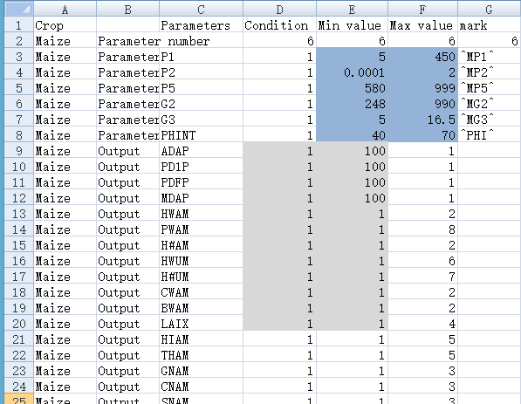
Group mark
Weight
Figure 3. Components of the ParameterOutput.csv file
2.2.3. Input file of "SimulationControl.csv"
This file contains the necessary information about DSSAT program installation, PEST operation and iteration times, random initial parameter vectors, and coefficient of variation (Fig. 4). Users need to set their own DSSAT installation path, selection ratio, and number of random initial parameter vectors. The remaining parameters can be set to their default values.
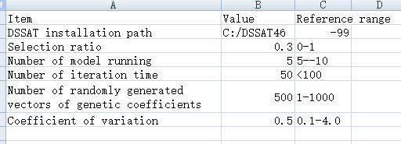
Figure 4. Components of the SimulationControl.csv file.
2.2.4. Main program file of "DSSAT_PEST.r"
This is the main R program for the DSSAT-PEST package and needs no modification.
2.2.5. Output file of "Cultivar Coefficients.txt"
Users can find the final optimized genetic parameters in this output file.
2.2.6. Output file of "ERROR.txt"
Error information is saved in this file.

2.3. Notices for running DSSAT-PEST
Before running the DSSAP-PEST package, users need to check and pay attention to the following points:
(1) Only one crop variety can be optimized at a time and only one experiment file (one X file) can be included at a time, however it can include many treatments of a given experiment.
(2) If there is no end-season observation data (or File A) available in the experiment file, the package will not run.
(3) Users can modify the "Parameter Output.csv" file according to literature or similar varieties, and set the maximum and minimum values for different crop genetic parameters.

3. DSSAT-PEST usage steps

3.1. DSSAT-PEST running steps
Taking the soybean experiment UFGA7901 with a variety of ‘IB0001 BRAGG’ in the DSSAT model database as an example, the specific steps of DSSAT-PEST application are illustrated as follows.
(1) Setting up DSSAT files
Set up the X file, A file, T file, soil file, and meteorological document in DSSAT.
(2) Running X file
Run the X file and make sure tp get the correct Evaluate.out file, which allows only one header line (the red box section in Fig. 5).
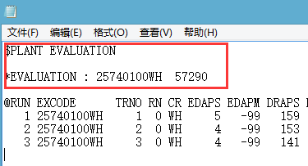
Figure 5. Structure of the Evaluate.out file.
(3) Setting up input files
Properly adjust the crop file named "CropCultivar.csv", the parameter file named "ParameterOutput.csv", and the control file named "SimulationControl.csv". For "CropCultivar.csv" (Fig. 2), users need to modify the flag values and fill in "Cultivar Name". For example, the crop type is soybean and the name is "IB0001 BRAGG". Therefore, the corresponding "Flag" is "1" for soybean and "0" for the other crops. The soybean variety name is "IB0001 BRAGG".
For "ParameterOutput.csv" (Fig. 3), users need to modify "condition", "Min value Max value" and weight. "Parameter" item "condition = 1" means that the parameter is to be optimized, and "condition = 0" (default value) means the opposite. "Output" item "condition = 1" means that the output variable is the optimized objective, and "condition = 0" (default value) means the opposite. If Min value is equal to Max value in the parameter file, it means the genetic parameter does not differ among varieties and will not be optimized. The genetic parameters must be strictly between the minimum and maximum values, and not equal to those boundary values.
For "SimulationControl.csv" (Fig. 4), users need to properly set the path according to the installation path of DSSAT46. Special attention must be paid to the use of "/" or "\\", which is specially defined in the R language. Users need to appropriately set the number of random initial parameter vectors. A large number will dramatically increase the runtime, while a small number will lead to a local optimal solution. Generally, this number should be no more than 500. Users can modify the running times and iterations of PEST. Small numbers may fail to get the global optimal solution, while large numbers may lead to longer runtimes. Users can use the default value of the coefficient of variation or adjust it properly (Fig. 4).
(4) Running DSSAT-PEST
Open the main program "DSSAT_PEST.r" in Rstudio and click "Run" to run the program (Figs. 6 and 7). The time consumption will display when the program stops.
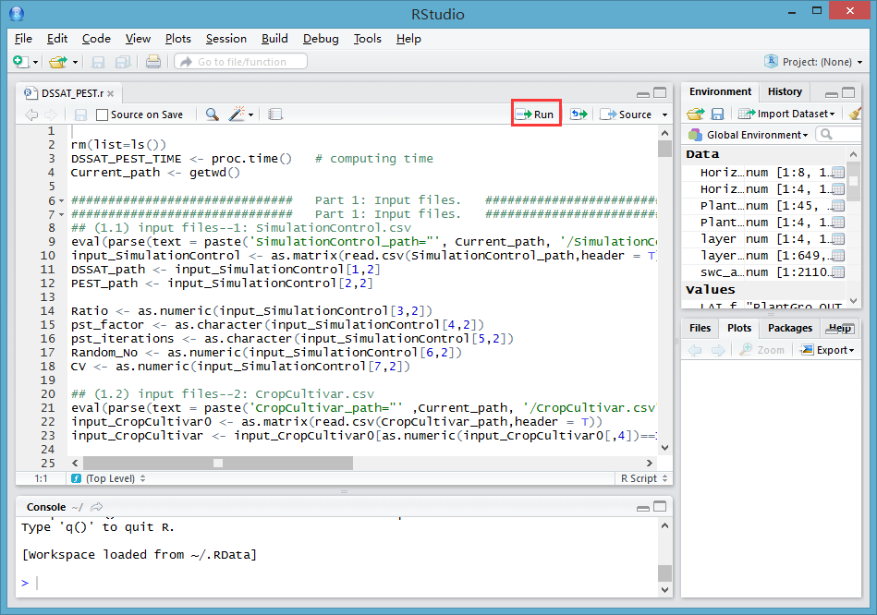
Figure 6. Screenshot of the running of the DSSAT-PEST.r script in Rstudio.
(5) Results of DSSAT-PEST
Open the DSSAT-PEST folder and check the output file named "Cultivar Coefficients.txt", which contains the final optimized genetic parameters (Fig. 7).
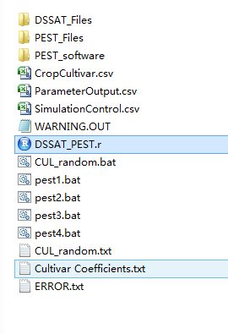
Figure 7. Position of the Cultivar Coefficients.txt file in the DSSAT-PEST package.

3.2. Comments on parameter estimation based on the DSSAT-PEST package
3.2.1. Some tips for parameter estimation
(1) Properly setting the initial parameter values
Users can find similar crop varieties by consulting literature or DSSAT database. The parameter range should be set according to the initial value, which can make the solution converge sooner and save runtime.
(2) Using wide parameter ranges when prior information missing
If it is difficult to get information about their own crop varieties, users can set wide ranges for the relevant genetic parameters and then randomly generate the initial parameter vectors within the ranges. Next, users need to optimize the generated initial parameter vectors based on the DSSAT-PEST package. In this way, the appropriate final optimal parameter set can be finally determined. However, the runtime will be very long and the optimization efficiency will be low.
(3) Appropriately adjusting the weights of output variables
If one or more output variables need to obtain better simulation results than the others, the weights of these relevant output variables can be increased appropriately. For example, in order to improve the simulation accuracy of yield at harvest maturity, users can increase the weight of the output variable HWAM.
3.2.2 Two strategies for parameter estimation
(1) Strategy I
Wider parameter ranges should be set and a large number of initial parameter vectors should be randomly generated (at least 500 vectors is recommended). This method can obtain more suitable initial genetic parameter vectors, but the runtime could be very long.
(2) Strategy II
A small number of initial parameter vectors will be randomly generated (e.g., 100 vectors is recommended) from wide parameter ranges, but multiple rounds of optimization will be carried out. Before each round of optimization, the parameter ranges should be gradually narrowed according to the optimization results of the previous round. Finally, the genetic parameter vector with the highest fitness value can be obtained after several rounds of optimization. This strategy consumes less time in each round of optimization but involves manual adjustment of parameter ranges.
References
He, J.Q., Gouis, J.L., Stratonovitch, P., Allard, V., Gaju, O., Heumez, E., Orford, S., Griffiths, S., Snape, J.W., Foulkes, M.J., 2012. Simulation of environmental and genotypic variations of final leaf number and anthesis date for wheat. European Journal of Agronomy. 42, 12.
Malone, R.W., Jaynes, D.B., Ma, L.W., Nolan, B.T., Meek, D.W., Karlen, D.L., 2010. Soil-test N recommendations augmented with PEST-optimized RZWQM simulations. Journal of environmental quality. 39(5), 1711-1723.
Nolan, B.T., Puckett, L.J., Ma, L., Green, C.T., Bayless, E.R., Malone, R.W., 2010. Predicting unsaturated zone nitrogen mass balances in agricultural settings of the United States. Journal of environmental quality. 39(3), 1051-1065.

